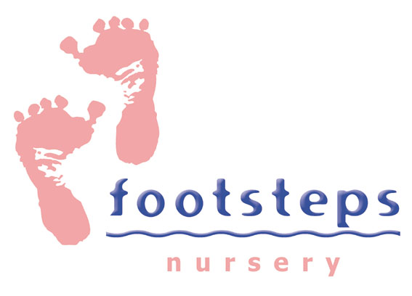


Equality and Diversity Monitoring Form

The Association is committed to the provision of equal opportunities in jobs and in housing, and that no Member, employee, tenant or potential customer shall suffer discrimination due to age, race, gender or gender reassignment, pregnancy or maternity, sexual orientation, religion or belief or disability.

The Association asks for your help in promoting this policy by completing this form.

The information given will be treated with the strictest confidence.

Would you please tick (✓) the appropriate boxes.

Post Applied For:

Where did you see this vacancy advertised?

Age: 16-24 ( ) 25-34 ( ) 35-44 ( ) 45-54 ( ) 55-64 ( ) 65+ ( )

Gender: Male ( ) Female ( ) Prefer not to say ( )

Gender Identity: If you identify as transsexual, transgender (in that you have effected a permanent change of gender identity) or as intersex which group do you identify with? Transsexual ( ) Transgender ( ) Intersex ( )

Ethnic Origin: Please tick against one of the following:

Asian or Asian British Mixed

( ) Bangladeshi ( ) Black and White Caribbean
( ) Indian ( ) Black and White African
( ) Pakistani ( ) Asian and White
( ) Any other Asian background ( ) Any other mixed background
Please specify below if you wish Please specify below if you wish

__________________________ __________________________

Black or Black British White

( ) African ( ) British
( ) Caribbean ( ) English
( ) Any other Black background ( ) Any other mixed background
Please specify below if you wish Please specify below if you wish

__________________________ __________________________

Chinese or Other Ethnic Group

( ) Chinese ( ) Any other
( ) Prefer not to say ( ) Please specify below if you wish

__________________________

Disability: Please tick against one of the following:

Do you consider yourself to have a disability under the Equality Act 2010.

Yes ( ) No ( ) Prefer not to say ( )

This information is provided for monitoring purposes only.

Religion or Belief: Please tick against one of the following:

( ) No religion ( ) Jewish
( ) Baha’i ( ) Muslim
( ) Buddhist ( ) Sikh
( ) Christian ( ) Other
( ) Hindu ( ) Please specify below if you wish
( ) Jain __________________________
( ) Prefer not to say

Sexual Orientation: Please tick against one of the following:

( ) Bisexual ( ) Gay Man/Homosexual
( ) Gay Woman/Lesbian ( ) Heterosexual/straight
( ) Prefer not to say

Thank you for completing this form. Please submit with your CV & Declaration Form.

