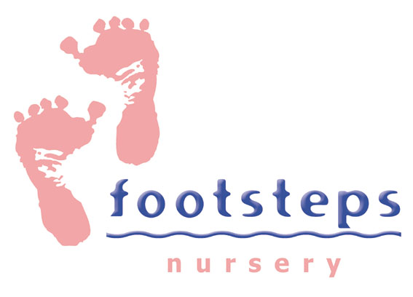

Footsteps Nursery is part of Westfield Housing Association and is Ofsted registered to provide early years education and childcare for children aged 6 months to 4 years and is seeking to recruit to the following posts:

Early Years Childcare Practitioners – 2 vacancies
30 hours per week - Monday to Friday
on a rota basis between the hours of 7.15 am and 6.00 pm
Based at The Minto Centre, Westfield, Workington

Annual salary range - £19,711 p.a. (30 hpw)
Rate of Pay - £12.60 per hour (the Real Living Wage) +
£150 payment upon successful completion of 6 month probationary period & Enhanced DBS Check.

Benefits include:

Excellent holiday package – 28 days annual leave per year + bank holidays
Employee discount scheme
Workplace pension scheme
Training and development opportunities
Free flu jabs
Employee Assistance Programme (24/7 confidential support for wellbeing and health)

We are looking for enthusiastic individuals who combine their knowledge of the Early Years Foundation Stage (EYFS) with a desire to provide high quality early years education and care for all children. If this describes you, we look forward to hearing from you.

Applicants must possess a diploma/level 2 childcare qualification or equivalent as a minimum as listed on Early years qualifications achieved in the United Kingdom - GOV.UK (www.gov.uk)
For a job pack and further information on how to apply please visit our websites
www.footstepsnurseryworkington.com
or www.westfieldha.org.uk
or call the Nursery on 01900 872011 for an informal chat.

Interviews will be arranged with shortlisted candidates.



